Nithin S
221IT085

IT253 Lab Assignment 2

Shell Programming

1. Write Script to see current date, time, username, and current directory
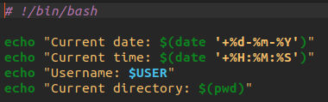

OUTPUT

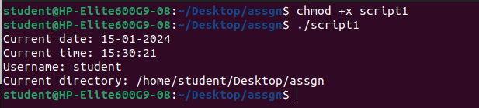

2.How to write shell script that will add two numbers, which are supplied as command line argument, and if this two numbers are not given show error and its usage

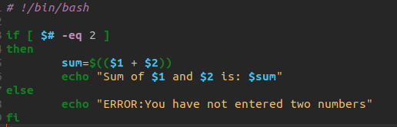

OUTPUT

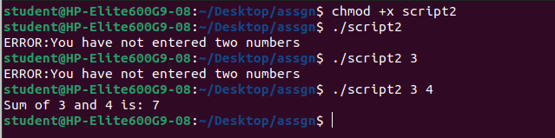
Uses of Command line arguments:

Customize script behavior by passing values during execution.
Control script flow with different options and switches.
Pass filenames or input data as arguments for processing.
Execute script parts based on provided options or flags.
Process each argument in a loop using "$@".
Display help or usage information with specific options.
Override default parameters using command-line arguments.
3.Write Script to find out biggest number from given three nos. Numbers are supplied as commandline argument. Print error if sufficient arguments are not supplied
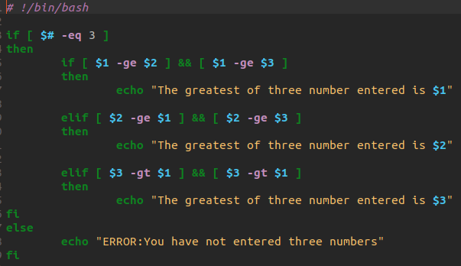
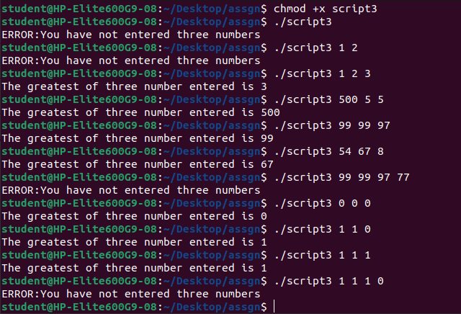
OUTPUT

4.Write script to print the following numbers as 5,4,3,2,1 using while loop.

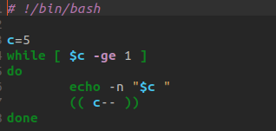

OUTPUT



5. Write Script, using case statement to perform basic math operation as follows: + addition, - subtraction, x multiplication, / division

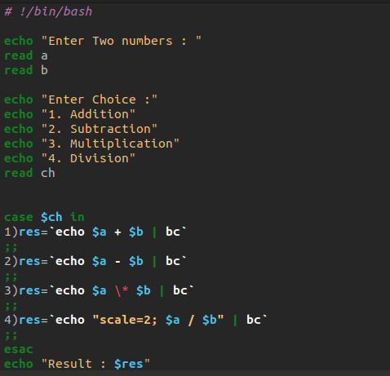

OUTPUT

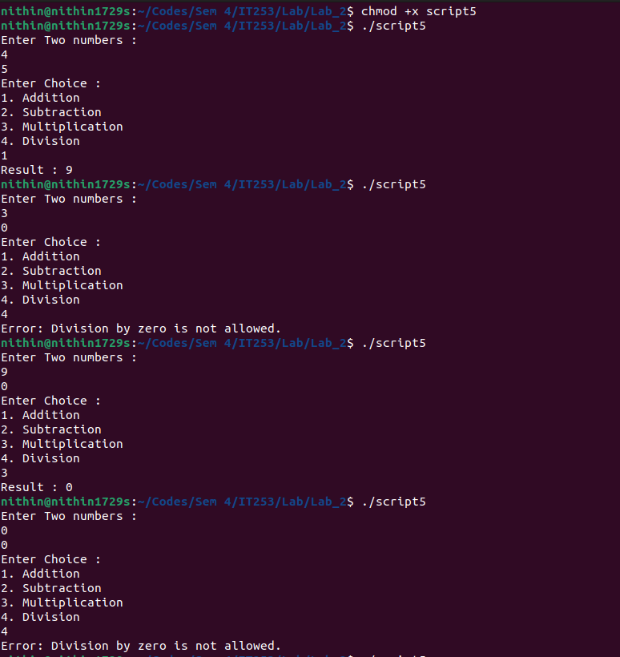

6. Write script to print given number in reverse order, for eg. If no is 123 it must print as 321.
(This code takes input as command line args)
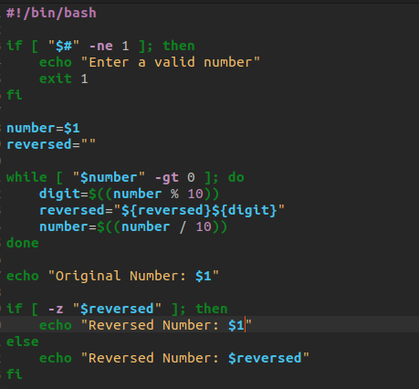

OUTPUT
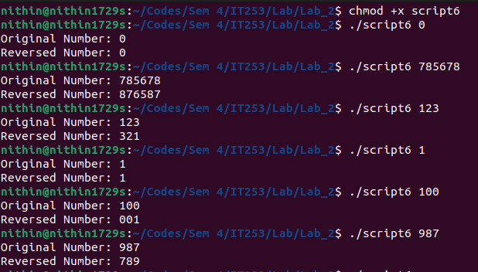
7. Write script to print given numbers sum of all digit, For eg. If no is 123 it's sum of all digit will be
1+2+3 = 6.(This code takes input as command line args)

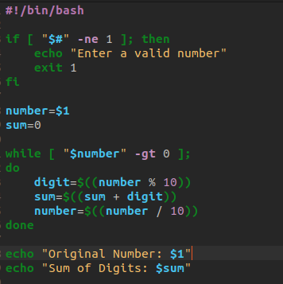

OUTPUT

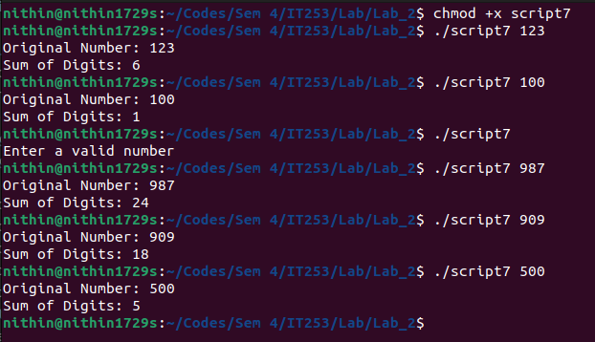
8. Write script to determine whether given file exist or not, file name is supplied as command line argument, also check for sufficient number of command line argument

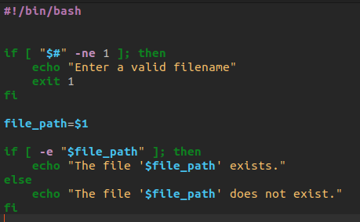

OUTPUT

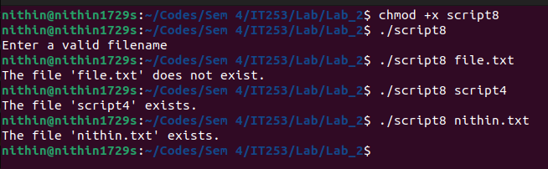

9. Write a shell script takes the name a path (eg: /afs/andrew/course/15/123/handin), and
counts all the sub directories (recursively).

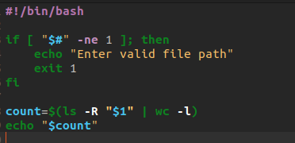

OUTPUT

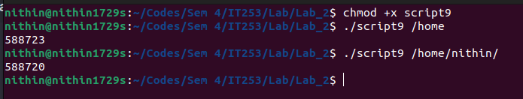

10. Write a shell script that takes a name of a folder as a command line argument, and produce a file that contains the names of all sub folders with size 0 (that is empty sub folders)

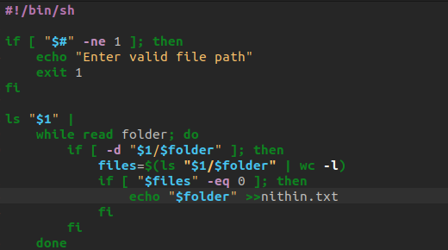
OUTPUT
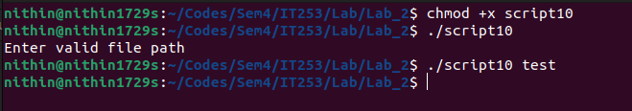
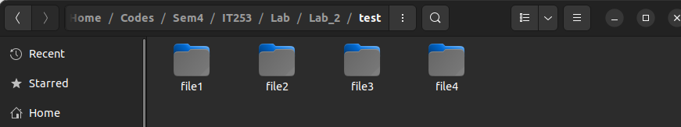
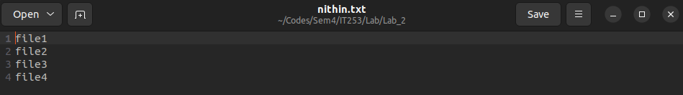

11. Write a shell script that takes a name of a folder, and delete all sub folders of size 0

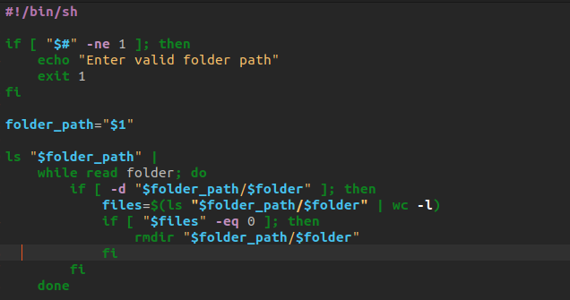

OUTPUT
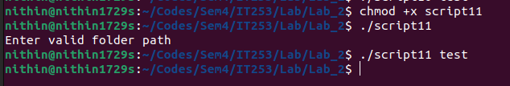
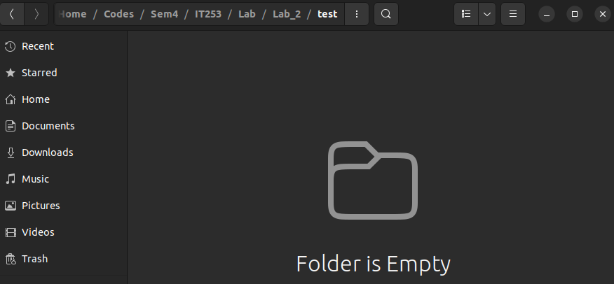
12. Write a shell script that will take an input file and remove identical lines (or duplicate lines from the file)

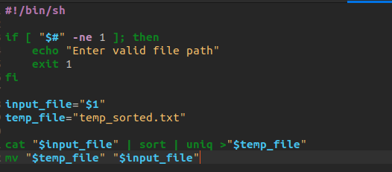

OUTPUT
